Luca Csepely-Knorr

Manchester School of Architecture

**Molnár, Farkas (1897-1945)**

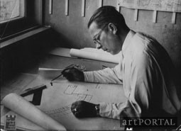

Farkas Molnár

<http://artportal.hu/files/imagecache/ill_big/files/kepillusztracio/MolnarFarkas.jpg>

Farkas Molnár, one of the most important representatives of 20th century Hungarian architecture, began his education in 1915 at the Hungaran Royal Academy of Fine Arts, studying drawing and painting. In 1916 he changed his mind, and started the architectural course at the Royal Joseph Technical University. He left the school without graduating, and joined the BAUHAUS in Weimar in 1921, where he worked for WALTER GROPIUS as well as the Architectural Department of the school.

During the period he spent in Weimar he concentrated on graphics and paintings, while also participating in OSKAR SCHLEMMER’S theatre workshop. Although at this time none of his architectural designs were realised, the ‘Red Cube House’, often appreciated as a landmark of his career, was created in this period, and was displayed during the 1923 Bauhaus exhibition.

Among the other well-known Hungarian members of the Bauhaus at the time, such as LÁSZLÓ MOHOLY-NAGY, MARCEL BREUER or Alfréd (Fred) Forbáth, he was the only one who decided to return to Hungary. In 1925 he re-enrolled to the Technical University, and completed his degree. After returning to his home country, he campaigned for better recognition of modern architecture and the principles of the Bauhaus movement. In 1929 he organised and became leader of the Hungarian section of the CONGRÈS INTERNATIONAUX D’ARCHITECTURE MODERNE (CIAM), and later of the mid-European section of CIAM-OST in 1937.

He started his own business in 1931 designing smaller scale villas. As Ferkai states, he appreciated these commissions as opportunities for experimental architecture for space utilisation, flexibility and inventive compositions. (Ferkai 1998) The success of these villas was acknowledged in 1933, as he received Triennale Award of Milan for the Villa Dálnoki-Kovács. The influence of the International Style can be traced in his designs for the Tyroler-house in Budapest as well. The idea of flexible space use was realised at the upper level of the flat, as the division of the rooms could be altered in twelve different ways.

Between 1934 and 1935 for a short period, he had a shared office with JÓZSEF FISCHER and Marcel Breuer. The success of their cooperation was marked by a winning entry in the architectural competition for the area and pavilions of the Budapest International Fair in 1934. Molnár cooperated with Fischer on the buildings of the Workers Hospital of the National Insurance Company (Országos Társdalambiztosító Intézet) in Pestújhely, Budapest.

His last, unfinished work was the Church of the Holy Land, with its strange elliptical mass and incomplete shell dome. Molnár was killed during the second World War by a bomb which dropped directly onto his apartment.

**List of Works**

1932 Villa Dálnoki-Kovács Budapest, Hungary

1932-35 OTI Apartment block, Budapest, Hungary (together with Bertalan Árkay, Sándor Faragó, Károly Heysa, Pál Ligeti, Farkas Molnár, Móric Pogány, Gábor Presich, Mihály Vadász)

1934 OTI Workers Hospital, Budapest, Hungary

1934 Tyroler House, Budapest, Hungary

1937 Peasants’ House Dévaványa, Hungary

1938-39 Holy Land Church, Budapest, Hungary

**References and further reading**

Bajkay, É. (ed) (2010)*Molnár Farkas: 1897-1945: építész, festő és tervezőgrafikus*. Pécs: Pro Pannónia.

Ferkai, A. (1998) ‘Hungarian Architecture between the Wars’. In: Wiebenson, D. and Sisa, J. eds. *The Architecture of Historic Hungary.* Cambridge, MA: The MIT Press. 245-274.

Ferkai, A. (2012) *Molnár Farkas*. Budapest: Terc.

Mezei, O. (1987) *Molnár Farkas*. Budapest: Akadémiai Kiadó.

**Visual material:**

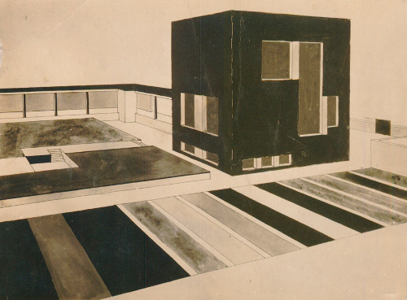

**‘Red Cube House’ perspective from the garden, 1922**

Copyright: Magyar Építészeti Múzeum. Budapest (Leltári szám: 74.01.169)/ Hungarian Architectural Museum

http://artmagazin.hu/content/_common/images/74.01.jpg

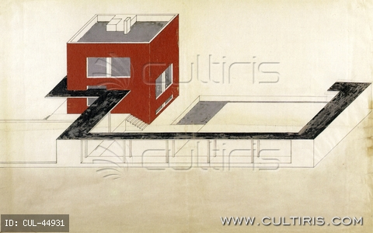

**‘Red Cube House’ axonometric, 1922**

Copyright: Deutsche Architekturmuseum, Frankfurt http://www.cultiris.com/kepek/thumb/44931/w/photo/artist-kaczur-gyorgy/molnar-farkas-epuletterv-1923.jpg

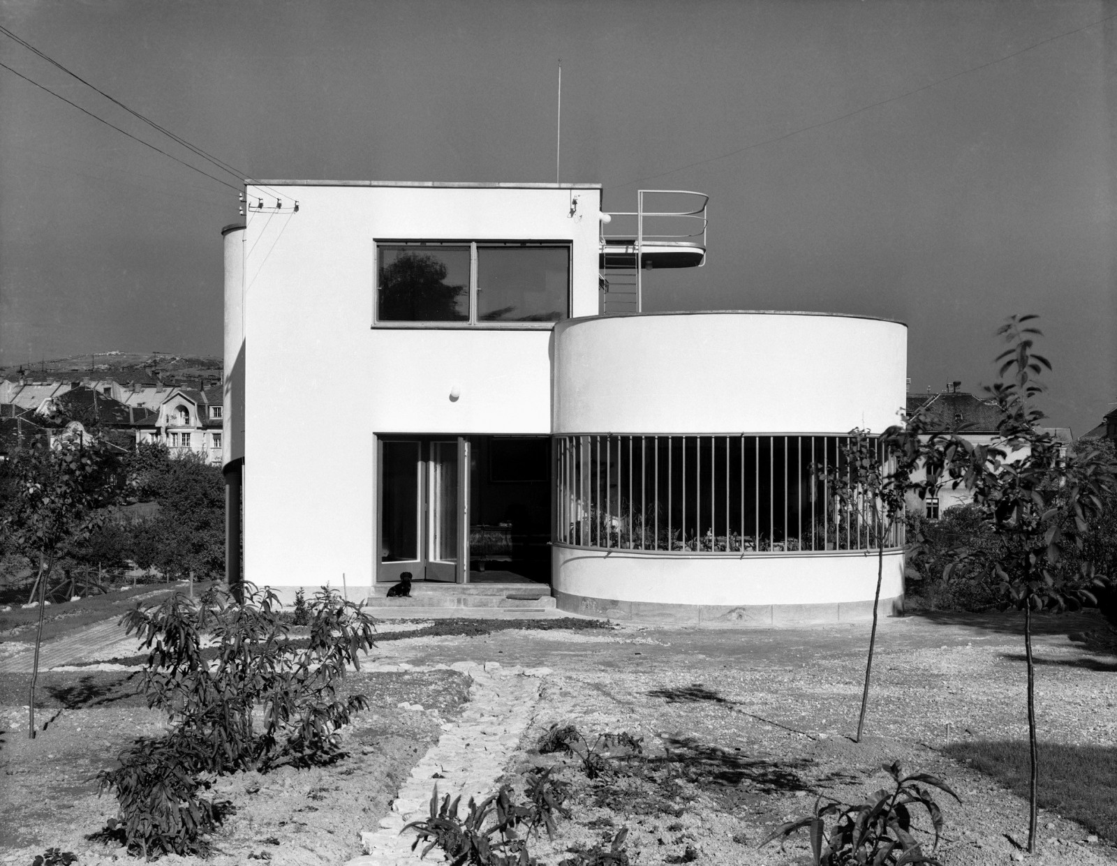

**Villa Dálnoki-Kovács, Budapest, 1932**

Copyright: KÖH Fotótár /

http://egykor.hu/images/2010/original/budapest-dalnoki-kovats-villa.jpg

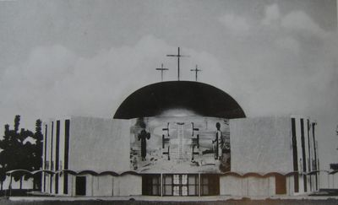

**Holy Land Church, Modell of the 2nd version**

Copyright: Magyar Építészeti Múzeum. Budapest /Hungarian Architectural Museum

http://www.budaipolgar.hu/data/cms81785/Magyar_Szentfold_elso_terv.jpg